Thermo-Mechanical Microstructure Optimization of composite RVE

IDAN DISTELFELD SHMUEL OSOVSKI

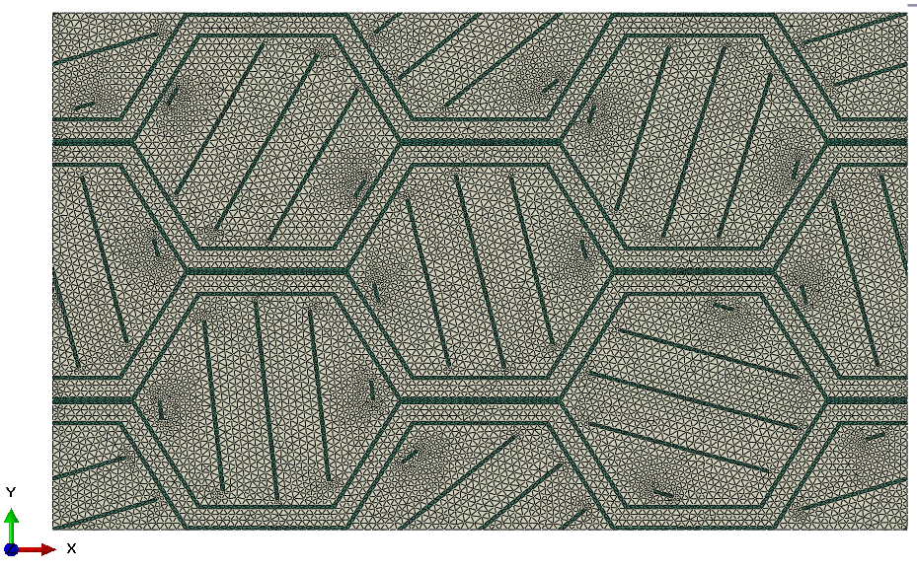

Table of Contents

1.Abstract: 4

1. Introduction: 4

2. Objective: 5

3. Approach: 5

3.1 The optimization problem: 5

3.2 Geometry and design variables : 6

3.3 Analysis: Finite Element Methods: 7

3.4 Data analasys-training a prediction model: 7

3.5 Optimization: 8

4. Background: 8

4.1 Composite materials: 8

RVE Homogenization : 9

Mechanical and Thermal Theoretical bounds : 11

Surrugate modeling: 12

DOE: 16

4.6 OPTIMIZATION 18

5. Method: 21

Defining objective function: 21

Material selection : 24

Model and FEM: 26

Meshing : 31

Simulation: 33

6. Results: 42

6.1 Exploring the design space : 42

6.2 Fitting a model: 49

6.3 Optimization: 53

58

58

7. FEM simulation failure 59

8.References: 59

## **Abstract**:

## Introduction:

Composite materials are in vast use in the Aerospace, Automotive and Sports industries due to their high Strength and Stiffness while having a relatively low density. Using composites, allows the designer to align the major material properties in the loading direction and while minimizing the structural weight.

Thus, expanding the physical boundaries previously known while designing using isotropic materials.

In the Spacecraft industry, the vehicle material set must withstand both mechanical and thermal loads while keeping the total weight to a minimum. Composite architectured materials are best suited for the job due to the wide variety of obtained properties , allowing the designer to control the properties by changing both the constituent materials and the microstructure.

Due to the conflicting nature of the mechanical, thermal and weight requirements , an optimization process must be performed in order to obtain an ideal microstructure with customized properties .

In recent years, the majority of microstructure related research is done numerically using methods as FE [], topology optimization[], inverse homogenization method[], or Fourier calculations[] to determine and optimize a microstructure for a given set of property goals.  
On the current work, we will design and optimize a composite microstructure for combined thermo-mechanical loading using FEA and RSM method .

1. Objective:  
   develop a method for creating and predicting effective composite microstructure elastic and thermal properties using RVE and a homogenization-based approach.  
   develop a method for optimizing composite microstructure for specific set of goals.

## Approach:

### The optimization problem:

The optimization problem can be defined as follows :

Minimize Density

Subject to E<Eg, G>Gg

K<Kg

## Background:

### Composite materials:

1. Composite materials are in vast use in the Aerospace, Automotive and Sports industries due to their high Strength and Stiffness while having a relatively low density. Using composites, allows the designer to align the major material properties in the loading direction and while minimizing the structural weight. Thus, expanding the physical boundaries previously known while designing using isotropic materials.
2. In composites, a soft and light matrix is reinforced with stiff metallic or ceramic particles to make a new, improved material with enhanced properties. Adding the reinforcement phase increase the material stiffness and strength while maintaining the ductility and low density of the matrix.
3. The extreme properties of composites have drawn tremendous attention from the engineering and research community since 1950 intending to improve the composite microstructures and macro properties. Some of the research areas were involved were manufacturing techniques, different material sets, and the effect of the microstructure -macro properties link. At first, composite research was combining complicated manufacturing techniques and conducting mechanical experiments.
4. Today, technology and computational power advancements allow making a low cost numerical experiments to get an insight regarding the material combination and microstructure in a fast and reliable way\

A structural composite is a material system consisting if two or more distinct materials ,whose performance and properties are designed to be superior to those of the constituent materials acting independently. The reinforcement phase is usually stiffer and stronger whose the matrix phase is softer and weaker. The properties of a composite material depend of the properties of the constituents, their geometry, volume fraction and the interaction of the phases. The distribution of the reinforcement determines the level of heterogeneity of the material system. The phases of the composite system play different roles ,which depend on the engineering application of the material. In the classical case , The reinforcement provide stiffening and strength to the structure .On the other hand the matrix phase provide the bonding , ductility and load transfer from one reinforcement phase to the other.[]   
composites have some dominant advantages over monolithic materials such as High stiffness , High strength ,low density and and adaptation for the intended use .The basis for the superior performance lies on the specific strength , stiffness (Strength or stiffness to density ratio) and the heterogenous properties of the material.  
known microstructures?  
Composites are generally divided into three categories depeneding on the constituent materials and fabrication methods :Polymer matrix composites (PMC) which are generally used in low temperature range (limited by the polymer matrix Tg) ,Metal matrix composites (MMC) that can be used in mid temperature range(limited by the metal melting point) and Ceramic matrix composites generally (CMC) generally used in very high temperatures.  
In this project we will deal with PMC type composites in the region below the low temperature range(~200[C]).

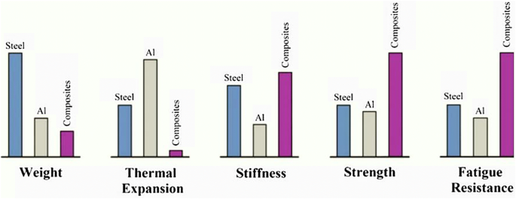

### 5.2 RVE Homogenization :

The RVE term was first defined by Hill and it can be described as the smallest volume element that can be representative of the material response at the macro scale .   
Generally , an RVE is used as a reduced model for the computation of effective properties ,in order accelerate and simplify the calculation.

Using RVE’s homogenization, requires the imposing of uniform strains over the RVE as well as periodic boundary conditions (PBC) to represent an infinite continuous space filled with RVE’s of the same type deforming the same way.

Usually, calculating the effective RVE properties in a selected direction is involving loading the RVE on the specific direction and averaging the material response over the RVE volume.

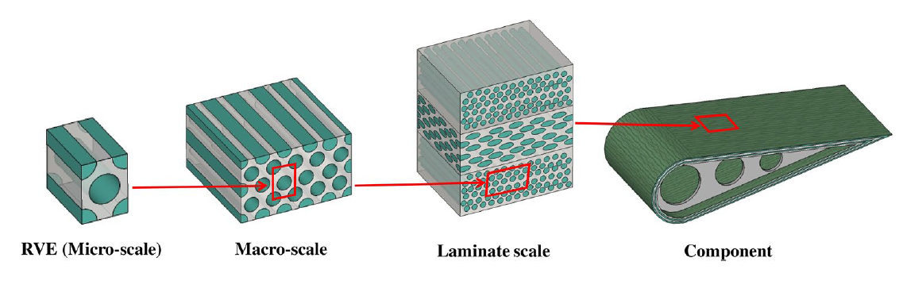

FEM BASED METHOD

Homogenization by FEM

FFT METHOD

Homogenization using fft method has gained a lot of attention in recent years due to its high performance . it was developed originally by Moulinec and Suquet and implemented in a relatively simple python code by Goose. The method calculates voxel based periodic microstructures reaction given some traction. The solution for the basic equations is made with an iterative solver until equalivrium is met .  
The Main drawback with this method is the voxel based microstructure: in order to have a decent representation of A complicated microstructure , a very dense represention of the volume has to be set, leading to higher computational time .

INVERSE HOMOGENIZATION METHOD

The inverse homogenization method developed by Sigmund used topological optimization in order to get an rve with specific requirements .using this method ,Sigmund develop a new kind of composite that is very similar to the suggested rve .

### 5.4 Surrugate modeling:

**surrogate based optimization:**

Straightforward optimization of a given objective function is not always practical.

Particularly, if the objective function comes from a computer simulation,

it may be computationally expensive, noisy or non-differentiable. In such cases,

so-called surrogate-based optimization algorithms may be useful where the direct

optimization of the function of interest is replaced by iterative updating and reoptimization

of its model - a surrogate

**Artificial Neural Nets:**  
Artificial Neural Nets(ANN) are mathematical inventions inspired by observations made in neuroscience .An ANN can be described as mapping an input space to a desired output space. This concept is analogous to that of mathematical function .ANN consists of input layer connected to several hidden layers and an output layer. The input layer represent the different input parameters. The hidden layers are the main f consists of many entities called neurons . each of the nuerons neuron has multiple connections to the previous and next layer neurons . using those connections , the input data is transferred from the input layer to the hidden layers and the output layer to make the final prediction.  
A single neuron is defined by his set of weights , bias and a transfer function .the weights are a measure of strength of the connection between one neuron to another . the bias is a scalar that acts as a threshold value for the neuron activation. The transfer function is a nonlinear function that maps the neuron weighted sum with the threshold value to the neuron output . the transfer function enables the model to account for non linearities in the input -output mapping .The process cab be defined mathematicly by Eq. ()

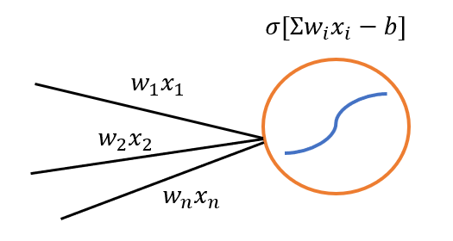



**Backpropagation -training:**  
In order to train the network predict the input-output relation we need to define a cost function. This function will grade the network performance when mapping the inputs to the outputs . One usefull method in network regression is defining a Mean Square Error(MSE) cost function which simply substracts the prediction values from the real output values ,squaring and averaging over the number of examples checked in the session or batch. Using this method, causing the network to address the most erroneous datapoints with greater weight.  
our goal while training the network is to minimize the cost function, as 0 value of the cost function is perfect prediction while higher values implies erroneous prediction.  
The minimization of the cost function is made by using back propagation algorithm. This algorithm is first passing the training data through the untrained network in order to asses the cost function. Then, the weights and biases of the network are changed using gradient decent algorithm. This process is done in multiple iterations (epochs) until convergence.

**Training,Validation and Test data:**  
Usually ,the database is partitioned into 3 parts where the training is the data used for changing the weights a biases through the gradient decent and back propagation algorithm, the validation dataset is used through the training phase in order to asses the performance of the model on untrained dataset in order to prevent overfitting . it is not used to change the network parameters.the test dataset is used to examine the trained network on a data that it never seen before , differentiating it from the validation test.

**Gaussian process regression:**

This model is probalistic and it is based on gaussian distribution of each of the model variables .   
The base idea is that we can fit infinite number of functions thru our data set , the model will give us the mean function as well the std at each point .  
First, the algorithm is calculating the covariance matrix which determines the std for each variable as well as how linked the variables are to each other . the diagonal terms sets the std and the other terms sets the link .

  
later on , the algorithm is fitting the dataset using different kernels( base functions) as well as hyperparameters sigma and I which determines the variation level of the functions.   
The main problem about this algorithm is the scalabilty, the computation time is O(N^3) means that for very large datasets we cannot use the model . to solve this problem, there are some method that use only part of the data. This method result of course in a lower accuracy data.  
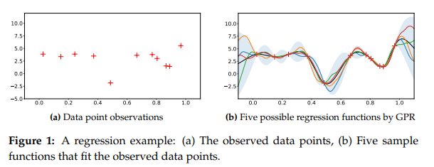

Kernels:

Kernel is the base function for the covariance , it is account for how the data changes the main function

Basis functions is a bias for the the result

Length scale hyperparameter is the amount of fluctuation in the function as a result of a single parameter.   
Std is the standard deviation and it is common for all parameters.

In order to have a decent fitting to the data, we have to optimize the hyperparameters so our function will not be too fluctuating or to shallow.

### 5.5 DOE:

**Latin hypercube**

**Latin hypercube sampling** (**LHS**) is a [statistical](https://en.wikipedia.org/wiki/Statistics) method for generating a near-random sample of parameter values from a [multidimensional distribution](https://en.wikipedia.org/wiki/Multidimensional_distribution). In the context of statistical sampling, a square grid containing sample positions is a [Latin square](https://en.wikipedia.org/wiki/Latin_square) if (and only if) there is only one sample in each row and each column. When sampling a function of {\displaystyle N} variables, the range of each variable is divided into {\displaystyle M} equally probable intervals. {\displaystyle M} sample points are then placed to satisfy the Latin hypercube requirements; this forces the number of divisions, {\displaystyle M}, to be equal for each variable. This sampling scheme does not require more samples for more dimensions (variables); this independence is one of the main advantages of this sampling scheme. Another advantage is that random samples can be taken one at a time, remembering which samples were taken so far.

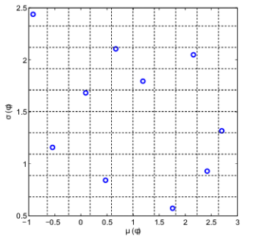

### 5.6 OPTIMIZATION

The goal is to optimize the geometry parameters for a given set of objective function constants. In order to have a fundamental understanding of the physical changes that can be obtained, we want to explore the design space by generating DOE to span all the parametric space. After calculating sufficient design points , we can fit our data with a model that can fit a continuos multi dimensional function and predict unexplored design points .This method is called Response surface method (RSM).  
The model can be made using 2nd order polynomial fit, Kirging or Neural network. In the final step we can use the continuous function in order to use gradient based optimization to find the optimal points even though we did not calculate it .

Optimization techniques, or algorithms, are used to find the solution to the problem specified in Eq. 1. The procedure consists of finding the combination of design variable values that results in the best objective function value, while satisfying all the equality, inequality and side constraints. Note that for many problems, more than one optimum (referred to as local or relative optima) may exist. There are many options for classifying the available optimization techniques. Algorithms can be classified

as gradient-based (or derivative-based methods) and gradient-free (or derivative-free

methods).

**Gradient based algorithms :**

Most local optimization algorithms are gradient-based. As indicated by the name, gradient-based optimization techniques make use of gradient information to find the optimum solution of Eq. 1. Gradient-based algorithms are widely used for solving a variety of optimization problems in engineering. These techniques are popular because they are efficient (in terms of the number of function evaluations required to find the optimum), they can solve problems with large numbers of design variables, and they typically require little problem-specific parameter tuning Gradient-based algorithms typically make use of a two-step process to reach the optimum. This two step

process can be explained using the following picture (Vanderplaats, 2007) of a blindfolded boy on a hill. The boy has to reach the highest point on the hill (the objective function), while staying inside the fences (the constraints). The design variables are the x and y coordinates of the boy

In an analogy to gradient-based optimization, the blindfolded boy can reach the top of the hill by taking a single step in the x direction and another step in the y direction. Based on the information gained from these two steps, he can estimate a direction that would take him uphill. The boy can then start walking in this direction until no more progress is made, which may include reaching a fence. At

this point the boy can again take two small steps to determine a new direction that will take him uphill,

while staying inside the fences, and continue the process until he reaches the top of the hill.

. These algorithms,

however, also have several drawbacks which include that they can only locate a local optimum, they have difficulty solving discrete optimization problems and they may be susceptible to numerical noise .  
**Genetic algorithms:**

Evolutionary optimization algorithms have become very popular in the last decade or two due to their simplicity and robustness when solving optimization problems . Unlike the local techniques, where a single design point is updated (typically using gradient information) from one iteration to the next, these algorithms do not require any gradient information and typically make use of a set of design points (generally referred to as a population) to find the optimum design.

GA method is an evolutionary algorithm inspired by Darwin’s principle of survival of the fittest .It is having the advantage of being extremely robust, having an increased chance of finding a global or near global optimum, being easy to implement and being well suited for discrete optimization problems .

The basic steps of a GA are illustrated in Fig Xx below. The first step is to create a random

initial population. The population is then ranked, based on the fitness (objective function) of each individual. The parent designs are selected in such a way that the higher ranked (fitter) individuals have a higher probability of being selected. The next generation is then filled

with children designs, created by randomly mixing the selected parent design properties (crossover) and imposing a randomized properties change ( mutation).

In order to keep the best solutions in the population and speed up convergence, the best solutions (elite) are passed onto the next generation without change(Elitism).  
The new generation is again ranked, and the process is repeated until convergence.

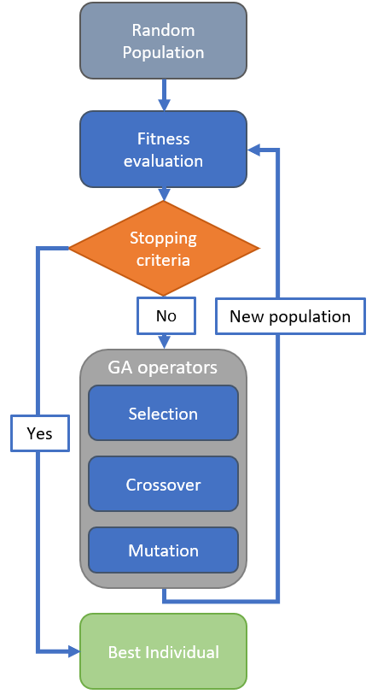

Multi Objective optimization (NSGA II):

Non Dominating Sorting Algorithm II(NSGA II)[] is a multi objective optimization evolutionary algorithm .

After the initial population has been generated it is sorted based on dominance of the individuals with respect to each other .For example,In the figure xxxx individual no 2 is dominating individuals 4,5,6 and is not dominated by any individual implying that it is part of the first frontier. The final ranking represent the frontier which the individual is part of. in order to rank the importance of individuals in the same frontier level, a crowding distance sorting step is performed . a crowding distance is a measure of the distance to the nearest neighbors . both the df1 and df2 distance is calculated and summed to get the final result . The best ranked individuals in the frontier will be the ones with the highest crowding distance score . Using this method reduces the risk of over crowded or vacant areas during the optimization process.  
after the population is ranked with the frontier and crowding distance metric , the next generation is made using the crossover, mutation and elitism operators .  
the population is then ranked again and a binary selection process is made in order to ensure survival of the fittest. The process is then repeated until a stopping criteria has met.

|  |
| --- |
|  |
|  |
|  |

## Method:

### Defining objective function:

**Goal Objective function:**

A third function can be defined in order to make a goal based optimization . The concept deals with complying with a set of goals or constraints while minimizing a property.

We define normalized properties:



Cost function:  
We would like to define a function that will grade the resulted properties as a function of the goal properties defined in the objective function . In addition ,we seek for fulfillment of the goals and then minimization of the weight , hence the density function will be dependent on the normalized properties.

As well we can define the goal and the weight function:





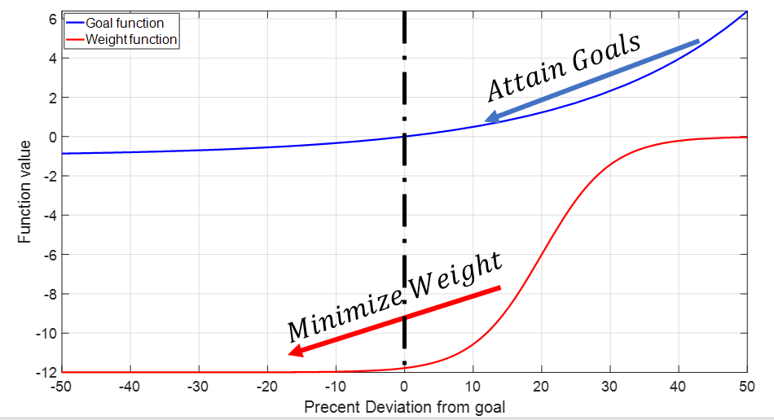

### Geometry and design variables :

The Geometry modeled in this work was inspired by a polycrystal metallic grain structures often found in high strength metals .In metals, the individual grains are arranged in a different directions resulting in a stiffer and higher strength material .   
Our modeled microstructure consist of a honeycomb structure filled with resin and reinforcing fibers .Due to the bending nature of honeycombs the webs of the honeycomb is designed as a sandwich structure filled with light matrix material. The resin will enhance isolation capabilities and reduce the RVE density While the reinforcement material will provide stiffness. In addition , Reinforcing fibers is added to the hexagonal central void in order to increase stiffness and strength in selected directions .The RVE consisits of 8 inidividual honeycomb cells with fibers oriented in independent directions .

|  |  |
| --- | --- |
|  | Plastic Deformation Behavior in Steels during Metal Forming Processes: A Review- By Sanjeev Kumar and Erwin Povoden-Karadeniz |
|  |  |

The Geometry can be described using 12 Different design variables:

1. Web thickness – Thickness of the Honeycomb webs . ranges from 1 to 3.
2. Isolation thickness fraction- Isolation width as function of the web value . ranges between 0.25 to 0.75
3. Fiber clearance-Distance between one fiber to the next in the same cell. Was set to be 2*Web ( Can be reduced to 1.5 to increase Vf of the reinforcement)
4. Fiber Width-width of the fibers inside the hexagon. Was set to be equal to the reinforcement width in the web.

5-12 . Cell Fiber angles(8)-Fiber angles in the 8 individual cells .

Parameter reduction:  
For simplicity reasons , X length of the cell is constrained to have constant value , thus any change in web width will result in the change of (a).

Model impl

### 6.2 Material selection :

Material selection is of great importance in our design problem. The properties of the constituent phases will have a major impact both of the property range that can be achieved and on the final optimized geometry. The different phases have to fit to the following requirements :  
High modulus and strength , low density , low thermal conductivity . The matrix phase should more ductile and energy absorbent in order to properly transfer the load. Retain of the mechanical properties under 200[C] temperature .  
Under the following requirement and constrains , we can use ashby charts to fit our selection criterion( fig XXX)

|  |
| --- |
|  |
|  |

Ceramics is the best fitting our reinforcement criterion. Some of the cadidates include Alumina ,Zirconia and Glass .Titanium is also a decent choise due to its high specific strength and modulus as well as low thermal conductivity.   
 High temperature Polymers is fitting our matrix requirement due to their relatively low density ,thermal conductivity and their high strength . Some of the popular choises for PMC for high temperature environment include : BMI resin ,Polyimide resin,Cyanite ester resin.

|  |  |  |  |  |  |  |  |
| --- | --- | --- | --- | --- | --- | --- | --- |
| Name | Density | Modulus of elasticity | Failure strength | Elongation | Thermal Conductivity | Max service temp | Manufacturing |
| Ti-6av | 4.45 | 110 | 1170 | 10% | 7.1 | 900 | 3D,CNC |
| Glass | 2.5 | 70 | 40-250 | 4-5% | 0.2 | 400 | CNC? |
| Macor | 2.52 | 66.9 | 94 | 4-5% | 1.4 | 700 | CNC |
| Aluminum oxide | 3.9 | 350 | 460 | 0.1% | 30 | 1000 |  |
| Zirconia | 5.6 | 200 | 330 | 0.2-0.3% | 3 | 500 |  |

https://www.mit.edu/~6.777/matprops/polyimide.htm

|  |  |  |  |  |  |  |  |
| --- | --- | --- | --- | --- | --- | --- | --- |
| Name | Density | Modulus of elasticity | Failure strength | Elongation | Thermal Conductivity | Max service temp | Manufacturing |
| Polyimide | 1.42 | 2.5 | 50-150 | 3% | 0.12 | 300 | Hot compression moulding |
| Cyanite ester | 1.2 | 2.9-4.3 | 50-150 | 5% | 0.2-0.4 | 350 | Casting |
| BMI | 1.2 | 3.5-4.5 | 50-150 | 4% | 0.3 | 250 | Casting |

### 6.3 Model and FEM:

Geometry:

Geometry definition and creation:

|  |  |
| --- | --- |
|  |  |

Second step: mirroring:

From lower face in y axis direction

From right face in x axis direction

Mirror from the right face to x axis   
Mirror from top face in Y axis

**Fibers creation :**  
For simplicity reasons , The fibers will be contained in the inscribed circle for each cell .   
First , 4 crossing point between the fiber and circle is found by circle solver func.  
Later , the fibers are trimmed so they will be rectangular by rect fiber func., at first the script is creating fibers advancing to the right until no crossing point is found between the circle and the fiber. later on, the fibers are advancing to the left in the same manner .

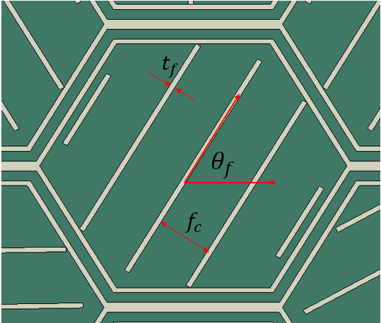

At first , the middle cells are created as they are the simplest to implement .  
Later on, the edge cells are created as they well full cells .  
Last , The edge fibers are eliminated using extruded cut method .

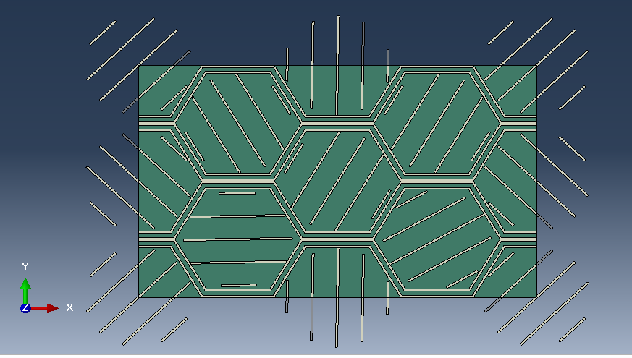

The cells are given the following indicies for fiber angle aligment.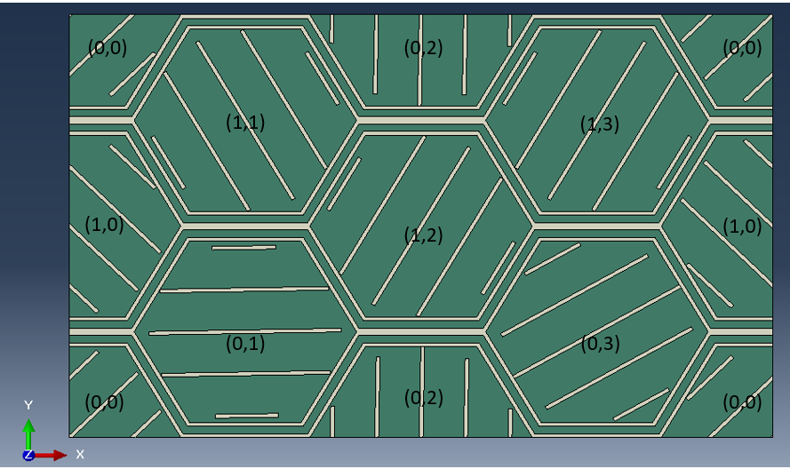

### 6.5 Meshing :

Since we are dealing with RVE, that is part of infinite continuum deforming the same way-a periodic boundry conditions has to be set . Periodic BC require periodic meshing for imposing node to node constraints . for this purpose , we used Gmsh [] Python package for creating and meshing the geometry. Gmsh package has a built -in command for periodic meshing and validating that the mesh nodes are perfectly matching in opposite RVE faces .  
After generating the mesh and validating that it is indeed periodic , an orphan mesh file is exported from the script .   
**Base Geometry creation:**  
The geometry is created using 2D gmsh entities which are extruded in the perperndicular direction in the final step .  
First , the containing rectangle is created . Later on , the top left webs are created individually. Those webs are then mirrored to the right and to the bottom by function mirror_cell() to create the honeycomb structure. After the base honeycomb structure has been defined , the creation of the inner reinforcement fibers is made by looping over the individual cells and fibers.  
For each cell , The fibers are defined using the intersection points between infinite fiber and a circle contained in the hexagon cell . If the number of intersection points is smaller than four(meaning that the fiber is splited along its width) the program stops the fibers creation process. For the peripheral cells , additional intersection points between the base rectangle and the fibers is calculated using shaply packge[] .   
After the individual reinforcement surfaces are built , they are used to cut the base rectangle using fragment () function in order to create the individual matrix surfaces.

**Meshing:**

First the model is seeded by a global seeding. Than ,the meshing is made using Delaunay triangulation algorithm . the algorithem Is maximizing the minimum angle for the triangles elements . lastly, the front plane nodes are projected to the back plane and 3d meshing is made using 4 nodes tetrahedral elements(first order)

**Periodicity :**

The mesh periodicity is made using periodic() function , the function is getting edge coordinates and translation value which corresponds with the rve length . In the first step , The original edge entities are found using bounding box algorithm. The program loops over all the edges that is included in the specific face and looking for the matching one in the translated area . Once found , the program sets both of the entities to have periodic nodes using the gmsh built in command .

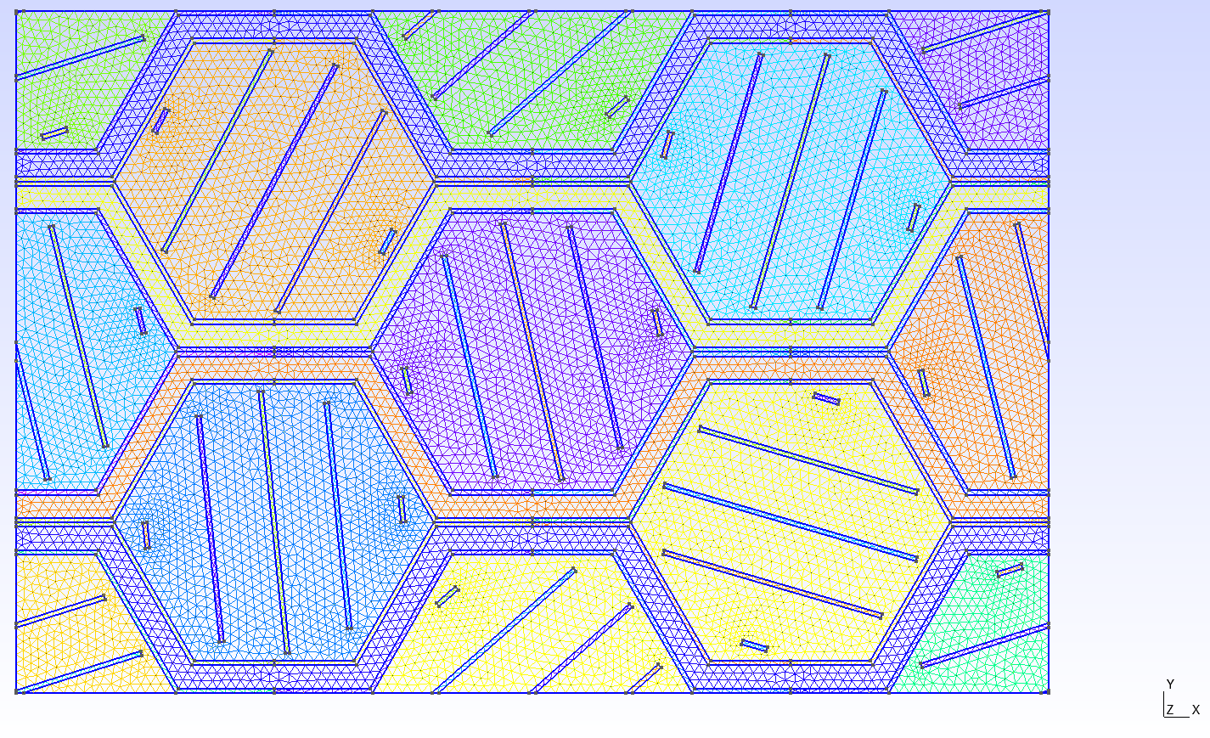

**photo describing how the surfaces are fitted**

### 6.6 Simulation:

#### Mechanical Simulation:

The mechanical calculation is made by easyPBC plug in developed by Sadik L. Omairey[]

The concept of RVE homogenisation is to numerically impose uniform strains to compute the effective elastic properties of a composite model, as can be seed in **figure xxx**

Generally, these strains are applied in several independent sets, with each set calculating specific elastic material properties, as detailed in Sect. 3.2. The RVE is assumed to

be a part of a periodic material, therefore, it is important to simulate the periodicity of the RVE with the surrounding material before and after being strained in FE software

The individual dofs is linked and constrained in order to impose perdiocly using the following concepets :

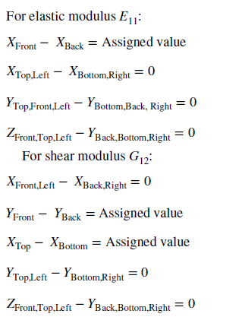

The strain value for all directions was changed to 0.2% of the specific direction length scale in order to be consistent with the physical definition of Elastic region.

Finding periodic nodes:



Post processing :

After the FEM job is done , the plug in calculated the equivalent properties as follows :

Young modulus:

Applied displacements on the RVE surface are resisted internally, creating boundary nodal forces at the displaced boundary surfaces. Those nodal reaction forces are extracted from the analysis for the principle direction of the loading . The equivalent stress on the loaded face is the sum of all the nodal reaction forces , divided by the face area. Then the main direction elastic moduli is calculated using the calculated stress value divided by the pre imposed strain value in the loading direction.

Shear modulus:

The shear moduli is estimated dividing the shear stress in the shear strain . First , the nodal shear reaction force is extracted and then divided by the total face area in order to obtain the shear stress.   
secondly, the rve shear angle is extracted dividing the corners normal displacement in the face relevant length.lastly, the moduli is extracted, Dividing the stress with the shear angle using formula xxx .

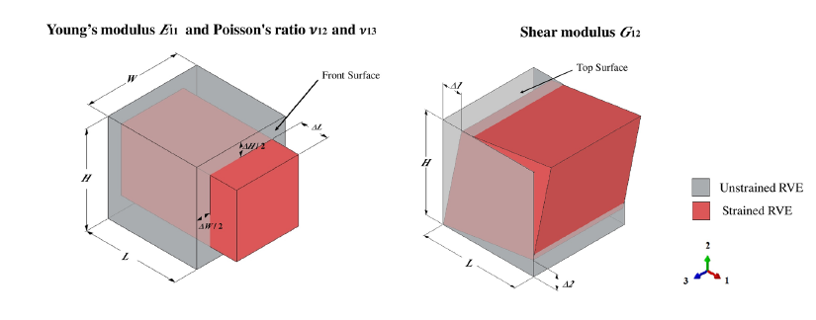

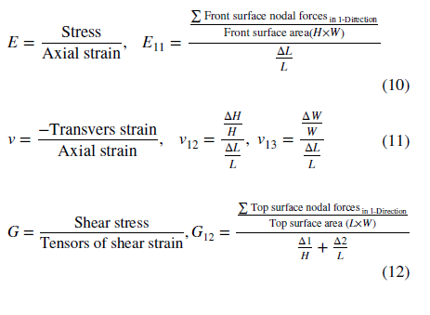



|  |  |  |
| --- | --- | --- |
|  |  |  |
| E11 | E22 | G12 |

#### Thermal Simulation:

The thermal rve homogenization is made using Micro-Mechanics plug in for imposing periodic BC and job creation, and by a Python script to make the post processing phase .

**BC Types:**

Periodic: imposes uniform temperature diffrence on opposite faces , in order to calculate averaged thermal conductivity need to compute average flux over the nodes in the direction normal to the faces of the bc.

The plug in makes 3 different analasys :

Kx,Ky,Kz.



|  |  |
| --- | --- |
|  |  |

#### Validation:

**Ud cell validation**

Quad vs Tri mesh:

|  |  |  |  |  |  |  |
| --- | --- | --- | --- | --- | --- | --- |
| Element Type | E11 | E22 | G12 | K11 | K22 | Runtime |
| Quad | 5.077 | 5.925 | 2.090 | 0.646 | 0.497 | 474 |
| Tri | 5.181 | 6.074 | 2.157 | 0.649 | 0.502 | 254 |
| Difference | 2.04% | 2.51% | 3.20% | 0.40% | 1.00% | 86.0% |

|  |  |
| --- | --- |
|  |  |

#### Convergence:

Converge of the simulation was checked for different base geometries (Honeycomb pattern).  
In order to minimize simulation run time ,and due to the fact the the model is comparative for optimization purpose : all the models was set to have 60,000 elements ( seed size of 1/100 the rve size ). This type of mesh will result in 3,2,5 precent maximum error for E1,E2,G12 for the mechanical case and 0.7,1 precent maximum error for K1,K2 for the thermal case . It is to be noted that as the simulation mesh refines , the models became softer and less conductive.

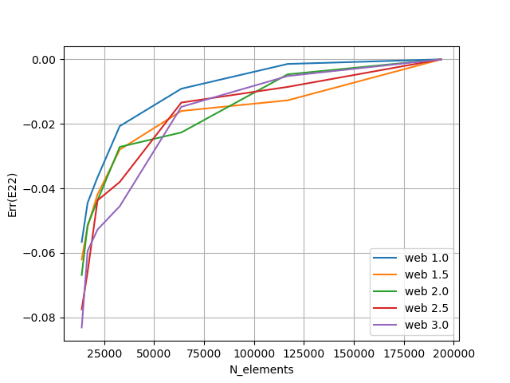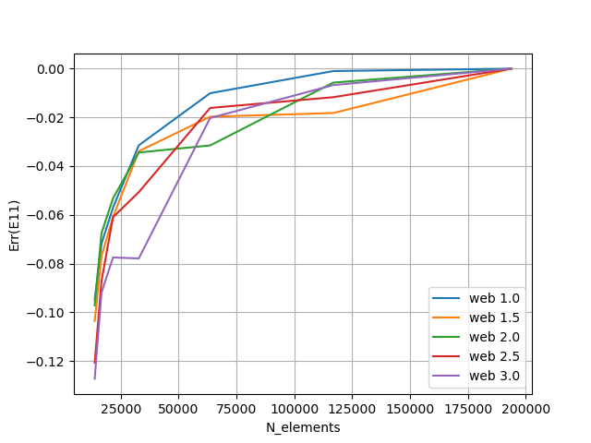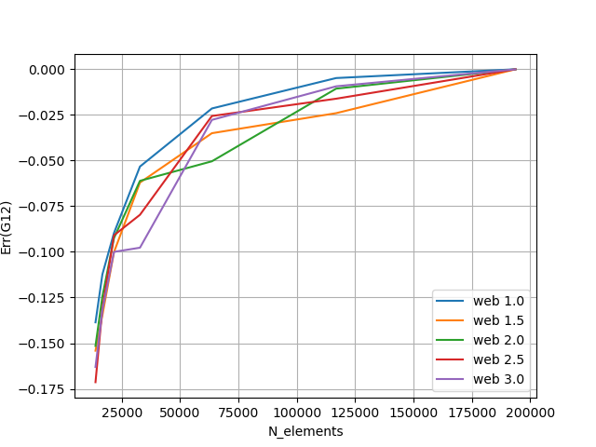

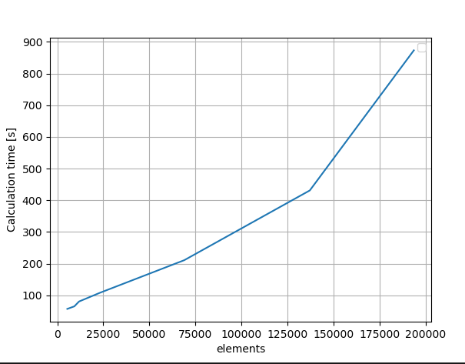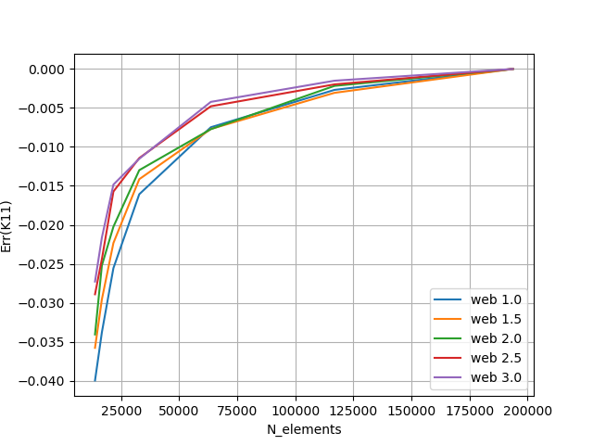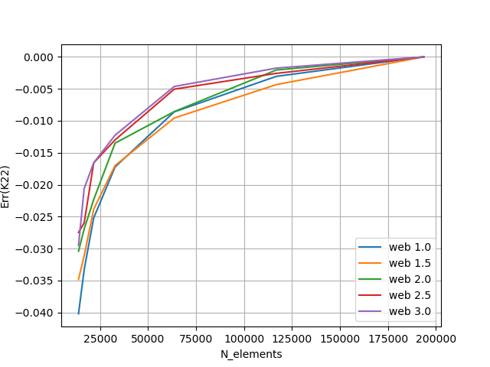

|  |  |
| --- | --- |
| **models** | **type** |
| **1-35** | **convergence** |
| **36-235** | **Web,angle1** |
| **236-1235** | **Web,angle1,angle2** |
| **1236-1272** | **Web=2,angle1** |
| **1273-1472** | **Web=2,angle1,angle2** |
| **1473-1492** | **Web=2,angle1=45** |
| **1493-1692** | **Iso,web,angles=45** |
| **1693-4692** | **All parameters** |

## Results:

|  |  |  |  |  |  |  |  |
| --- | --- | --- | --- | --- | --- | --- | --- |
| $$Materials$$ | $$Type$$ | $$E_{11}$$ | $$E_{22}$$ | $$G_{12}$$ | $$K_{11}$$ | $$K_{22}$$ | $$ρ$$ |
| $$Ti/PI$$ | $$min$$ | $$3.64$$ | $$3.40$$ | $$1.18$$ | $$0.37$$ | $$0.23$$ | $$1.57$$ |
| $$max$$ | $$10.25$$ | $$9.36$$ | $$3.70$$ | $$1.59$$ | $$0.81$$ | $$2.53$$ |
| $$average$$ | $$6.50$$ | $$5.84$$ | $$2.09$$ | $$0.82$$ | $$0.46$$ | $$2.07$$ |
| $$Macor/CE$$ | $$min$$ |  |  |  |  |  |  |
| $$max$$ |  |  |  |  |  |  |
| $$average$$ |  |  |  |  |  |  |
| $$Alu/CE$$ | $$min$$ |  |  |  |  |  |  |
| $$max$$ |  |  |  |  |  |  |
| $$average$$ |  |  |  |  |  |  |

### Exploring the design space :

**Changing iso thickness and web thickness-no fibers**

|  |  |
| --- | --- |
|  |  |
| 5077 | 5075 |

|  |  |  |
| --- | --- | --- |
|  |  |  |
|  |  |  |

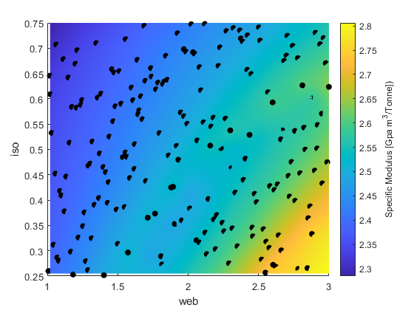



**Constant web size , equall angle to all cells**

The next step, was checking the fibers contribution to the elastic and thermal properties on the extreme case , when all of the fibers are tilted in the same angle.   
Examinig the results in the mechanical side, we can see that as expected ,the global maximum value of E11 and E22 are obtained in 0 and 90 deg respectivlty. Interestingly, the young modulus has a second local maxima located in 90 and 0 . The perpendicular fibers , Stiffens the honeycomb structure , preventing from the individual cell wall to bend and collapse. For the shear modulus, the maximum values are obtained in +-45 deg as expected.  
As for the thermal picture , The global minimum is obtained in 90 and 0 for K11,K22 respectevlty. The equal angle case demonstates the inherent conflict between the mechanical and thermal case – increasing the stiffness in a specific direction comes along with increase in the thermal conductivity .

|  |  |
| --- | --- |
|  |  |
|  |  |





**CONSTANT Web and 2 angles**

The second step was enabling the RVE’s fibers to be oriented in 2 different angles . In order to set all 8 cells a randomized angle , each angle sets the orientation of 4 individual cells .

|  |  |  |  |  |  |  |  |  |
| --- | --- | --- | --- | --- | --- | --- | --- | --- |
| Cell | (0,0) | (0,1) | (0,2) | (0,3) | (1,0) | (1,1) | (1,2) | (1,3) |
| Fiber angle | $$θ_{1}$$ | $$θ_{2}$$ | $${-θ}_{1}$$ | $$-θ_{2}$$ | $$θ_{1}$$ | $$θ_{2}$$ | $${-θ}_{1}$$ | $${-θ}_{2}$$ |

The resulted design points was imported to MATLAB and was fitted to a continuous response surface model using fitgrp() function .

|  |  |
| --- | --- |
|  |  |
| Model? | Model? |

**New figures with theta1,theta2 axes**

|  |  |  |
| --- | --- | --- |
|  |  |  |
|  |  |  |

**Changing web size and equal angles for all cells**

The third step was Examining the web-theta relation . Because the unit cell have a constant size , a big web size is resulting thicker fibers and in a smaller cell interior which leads to a decreased amount of reinforcing fibers per cell .

|  |  |
| --- | --- |
|  |  |
| 105 | 106 |

|  |  |  |
| --- | --- | --- |
|  |  |  |
|  |  |  |

We can see that as the web size decreases , the fibers domination in determining the RVE’s properties is increasing .

**Design space:**

The Last step was enabling all of the 10 design parameters .5000 simulations were run .

|  |  |
| --- | --- |
|  |  |
|  |  |

### Fitting a model:

Neural Network Vs Gaussian process regression :

A comparison was made using Neural network regression and Gaussian process regression.  
The regression test was held for the Ti/Pi E11 data (3500 Datapoints) with 10 predictor variables .  
Each model was optimized and validated with a 5-fold technique using Matlab functions(fitrgp, nn)   
Neural Network was found to be extremely fast and generate a good prediction model in a matter of a few seconds . gaussian process,on the other hand was slow to generate the model due to the numerical complexity of flipping a matrix O(h^3) But with a slightly improved accuracy .

NN network with 1 fully connected layer of 50 nuerons, tanh activation function , regulization strength (lambda)=1.486e-4Levenberg-Marquardt backpropagation

And standardize data.

GPR with matern 3/2 anisotropic kernel ,sigma =1.33e-4, standardize =false,basis function=zero

|  |  |  |  |
| --- | --- | --- | --- |
| Regression Method | Rsq | RMSE | RUNTIME |
| GPR | 0.93 | 0.0495 | 870.37 |
| NN | 0.91 | 0.0558 | 185.4 |

MSE E11 GRAPH

|  |  |
| --- | --- |
|  |  |

Altough its inferior prediction qualities , we chose to use the NN as the prediction model due to its relative high speed .The quick training will allow us to optimize the model and might get a superior result in terms of prediction accuracy. In addition, NN has the capability to predict multiple outputs at once , enabling to use a single model for all the RVE properties .  
First , an optimization for the number of neuron has been conducted , altering the number of neurons in the hidden layer and saving the training and test accuracy.  
In order to test the different networks on the same training and validation/test data, The data was partitioned into training (80%) and validation and test data( 20%) using indexed partition .  
The optimization result ,show an interesting result – increase on the number of neurons up to 50 brings an increase in the prediction accuracy for both the training and the test data. As the number of neurons exceeds 50, the training accuracy is increasing while the test accuracy is deteriorating .As the network size increases , it has the ability to memorize the training data and stops the generalization process -overfitting .



NN after setting the number of Nuerons for E11



NN for predicting all the properties :

Intrestingly , predicting a single value resulted in worse performace than predicting all the 6 properties at one network.

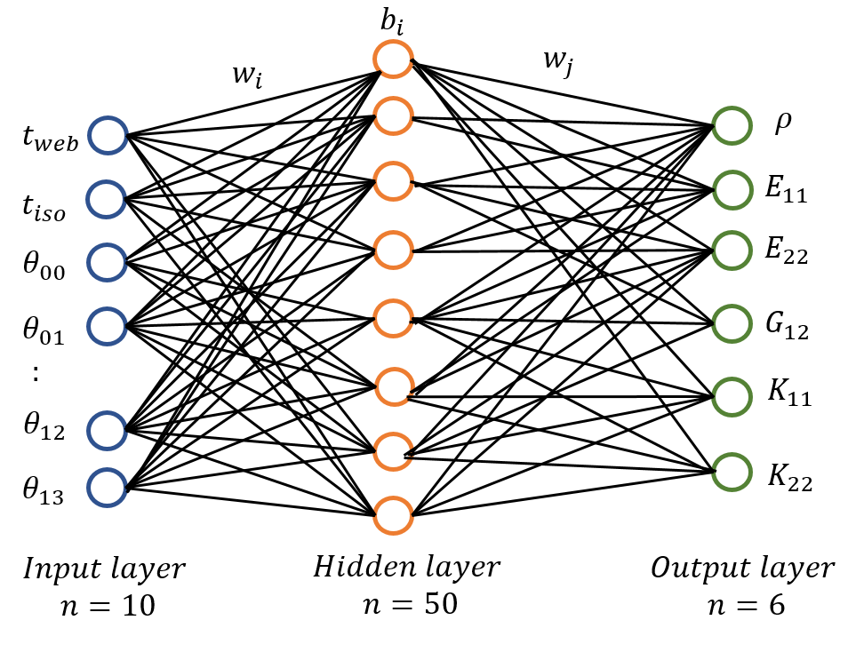



### Optimization:

#### Optimizing using goal function :

We start by using the goal function objective given by equation () . as we mentioned before, the function will tend to approach the goal values and then try to minimize the microstructure density. to set feasible goals, we shall look at the pareto front graphs in order to get a grasp of the trade off relation between the different properties . As a study case , we can select an optimal design area and try to get perferable solution based on predicted values. From the first figure we can see that E11=7.3GPA AND K11=0.6 is a pareto solution. We set E11_goal=7.3Gpa K11g=0.6 w\mk   
. Building a NN model for the objective function and optimizing using ga yields the following solution:

|  |  |  |  |  |  |  |  |  |  |
| --- | --- | --- | --- | --- | --- | --- | --- | --- | --- |
| web | iso | Theta(0,0) | Theta(0,1) | Theta(0,2) | Theta(0,3) | Theta(1,0) | Theta(1,1) | Theta(1,2) | Theta(1,3) |
| 1 | 0.75 | 0.01 | 0.01 | 0 | 180 | 0 | 179.97 | 0.02 | 180 |

Pluging in the resulted parameters and running the simulation yields :

|  |  |  |  |  |  |  |  |  |
| --- | --- | --- | --- | --- | --- | --- | --- | --- |
|  | rho | E11 | E22 | G12 | K11 | K22 | Obj | Best Obj |
| predicted | 1.676 | 7.43 | 4.50 | 1.04 | 0.474 | 0.23 | -4.61 | -2.86 |
| simulated | 1.677 | 7.1 | 4.13 | 1.2 | 0.484 | 0.22 | ~ | ~ |
| Error | 5.9e-4 | 0.046 | 0.089 | 0.133 | 0.02 | 0.045 | ~ | ~ |

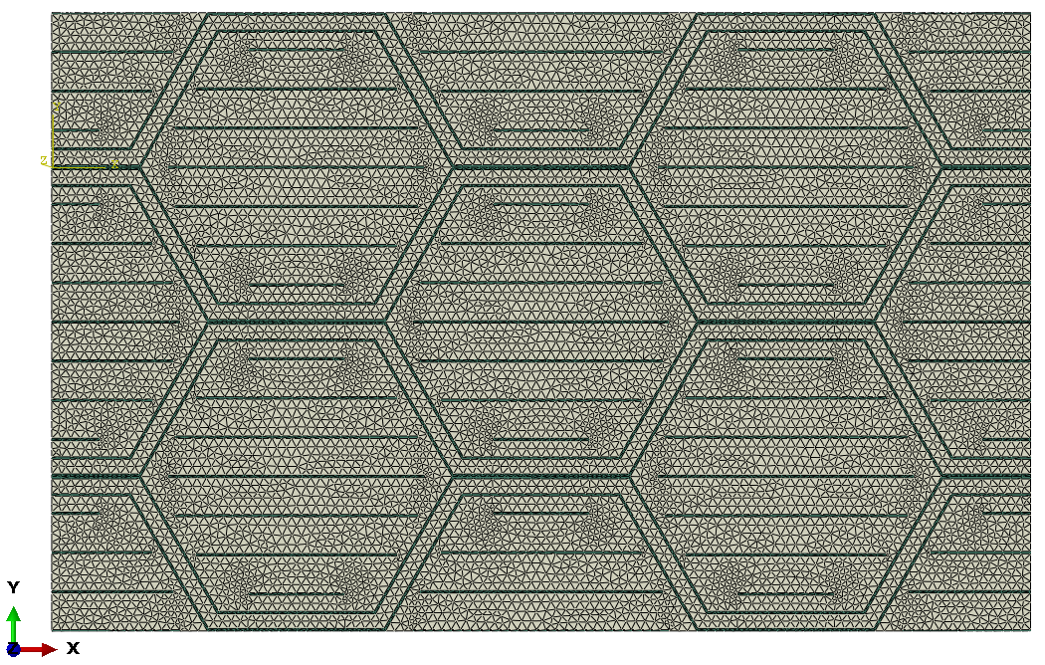

Goal G12=2.21 K22=0.6

|  |  |  |  |  |  |  |  |  |  |
| --- | --- | --- | --- | --- | --- | --- | --- | --- | --- |
| web | iso | Theta(0,0) | Theta(0,1) | Theta(0,2) | Theta(0,3) | Theta(1,0) | Theta(1,1) | Theta(1,2) | Theta(1,3) |
| 1.02 | 0.358 | 142.3 | 38.7 | 133.2 | 40.7 | 140.0 | 136.65 | 137.6 | 49.66 |

Pluging in the resulted parameters and running the simulation yields :

|  |  |  |  |  |  |  |  |  |
| --- | --- | --- | --- | --- | --- | --- | --- | --- |
|  | rho | E11 | E22 | G12 | K11 | K22 | Obj | Best Obj |
| predicted | 2.05 | 4.91 | 4.62 | 2.65 | 0.687 | 0.451 | -4.61 | -2.86 |
| simulated | 2.07 | 5.10 | 4.69 | 2.90 | 0.70 | 0.45 |  |  |
| Error |  |  |  |  |  |  |  |  |

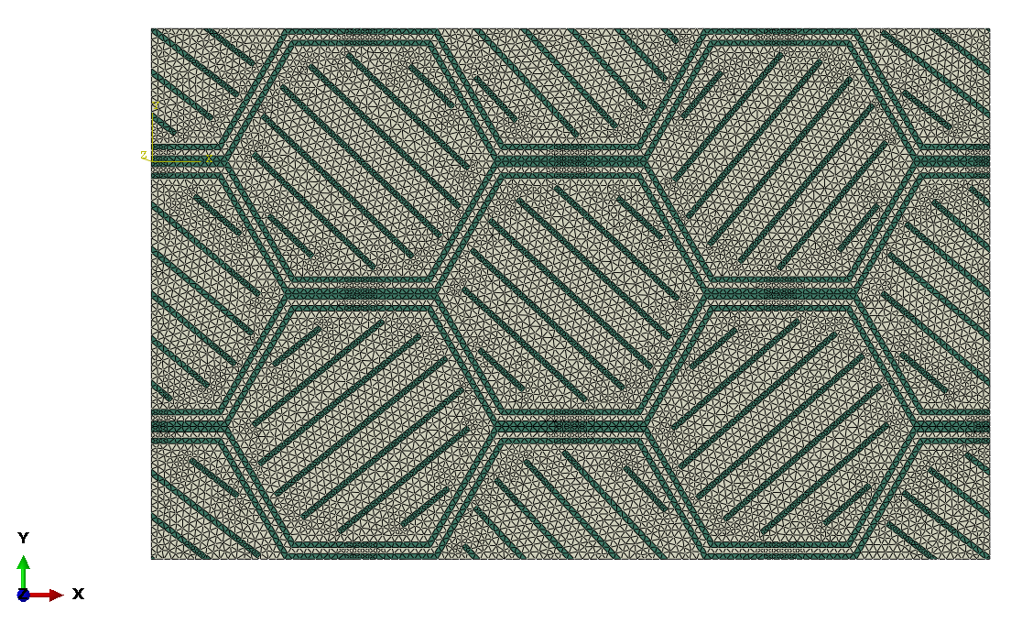

#### Multi objective optimization using NSGA 2

Due to the sensitivity of the optimization result to the goal function parameters , we decided to keep with the optimization prossess with Multi Objective optimization algorithm. This way the designer will have a Pareto frontier map of all the best solutions under the minimized/maximized parameters. The algorithms seeks to minimize multiple objective functions using comparison between the population in the nearest area.

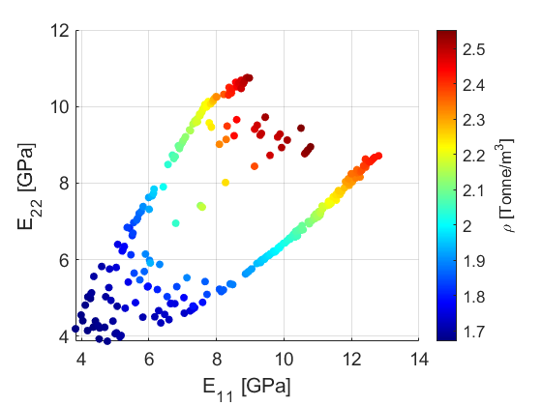

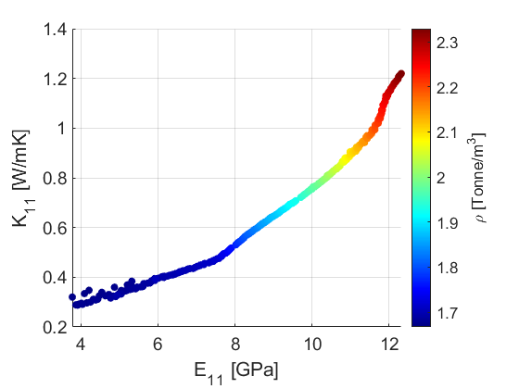

## 

## 

### 

## 7. FEM simulation failure

### 8.References:

**Materials:**

Material selection in mechanical design-Michael F. Ashby

**Composites:**

Engineering mechanics of composite materials -Isaac m Daniel ,Ory ishai

Introduction to composite material design- Ever J. barber

**Computational homogenization:**

Development of an ABAQUS plugin tool for periodic RVE

Mortazavi a,b,⇑, Julien Bardon a, Said Ahzi

Homogenisation- Sadik L. Omairey1 · Peter D. Dunning1 · Srinivas Sriramula1,2

Finite strain FFT-based non-linear solvers made simple- T.W.J. de Geus1,2,5, J. Vondˇrejc3 , J. Zeman4 , R.H.J. Peerlings2 , M.G.D. Geers2

Abaqus/CAE, Simulia. http://www.3ds.com/produ cts/simul ia/

portf olio/abaqu s.

Gmsh

**Models:**

Artificial Neural Networks: An Introduction- Kevin L. Priddy, Paul E. Keller

Gaussian Processes for Machine Learning- Rasmussen & C. K. I. Williams, Gaussian Processes for Machine Learning, the MIT Press, 2006

**Topology microstructure optimization:**

Design of three dimensional isotropic microstructures for maximized stiffness and conductivity- V.J. Challis a,*, A.P. Roberts a, A.H. Wilkins

Optimizing multifunctional materials: Design ofmicrostructures for maximized stiffness and fluid permeabilityJames K. Guesta,*, Jean H. Pre ́vostb

1. Topological design of structures and composite materials with multiobjectives-   
   Niek de Kruijf a, Shiwei Zhou b, Qing Li b,*, Yiu-Wing Mai

**Two-material Topology Optimization for the Design of**

**Passive Thermal Control Structures**

Pierre F. Thurier**1**, George A. Lesieutre**2**, Mary I. Frecker**3**, James H. Adair**4**

A new class of extremal composites

Ole Sigmund

MATERIALS WITH PRESCRIBED CONSTITUTIVE

PARAMETERS : AN INVERSE HOMOGENIZATION

PROBLEM

**OLE SIGMUND**

Design of masonry blocks with enhanced thermomechanical

performances by topology optimization- Matteo Bruggi, Alberto Taliercio

**Parametric optimization:**

Prediction of the Thermo‑Mechanical Properties of the SiCf/

SiC RVE

Model via FEM and Asymptotic Homogenization Method: Process

and Implementation Details- Xiuli Shen1 · Shuo Zhang1 · Xin Liu2 · Longdong Gong3 · Shaojing Dong1

Interphase effect on the elastic and thermal conductivity response of

polymer nanocomposite materials: 3D finite element study- Bohayra

Microstructure Optimization of Dual-Phase Steels Using a Representative Volume Element and a Response Surface Method: Parametric Study-TAREK M. BELGASAM and HUSSEIN M. ZBIB

Multiobjective optimization:

A Fast and Elitist Multiobjective Genetic Algorithm: NSGA-II Kalyanmoy Deb, Associate Member, IEEE, Amrit Pratap, Sameer Agarwal, and T. Meyarivan

Multi-Objective Optimization Using Evolutionary Algorithms: An Introduction Kalyanmoy Deb  
Review of Optimization Techniques-G. Venter

Babu, K. P., P. M. Mohite, and C. S. Upadhyay. "Development of an RVE and its stiffness predictions based on mathematical homogenization theory for short fibre composites." *International Journal of Solids and Structures* 130 (2018): 80-104.‏

**Hashin Shtikman objective:**

The goal is defining an objective function to summarize all the effective properties of the proposed microstructure into one objective. The goal is to maximize effective elastic modulus and shear modulus in all directions with respect to the volume fraction, as well as to minimize thermal conductivity with respect to the volume fraction.In addition, we want to normalize all the effective properties so the best result will reach the value of 1 and worst result will reach 0 value. This can be achived by using upper and lower bounds for both the mechanical and thermal properties .such Upper and lower bounds for properties was introduced by Hashin and Shtrikman. Addition arithmetic and harmonic bounds which called weiner bounds.



**Graphs showing that all results lay in within hs bounds**

**Specific values objective:**

Another objective function can be made using the specific stiffness values and thermal diffusivity of the rve’s :



### Mechanical and Thermal Theoretical bounds :

Voigt average or arithmetic mean has been derived in 1887 and is considered to be the upper bound for composite materials properties it is generally used to estimate the main direction properties of a ud composite material. Ruess estimate or Harmonic mean considers to be the lower bound for properties for composite materials . it is usually being used calculating transverse ud composite properties.

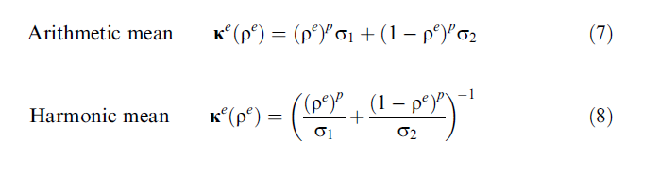

Hashin and shtikman also derived an upper and lower bounds for composites which are considered to be the tightest bounds for the effective properties



    
    
    

